**鮭の和風ムニエル**

|  |  |  |
| --- | --- | --- |
| 栄養成分（1人分） | | |
| 熱量 | 100 | kcal |
| たんぱく質 |  | g |
| 脂質 |  | g |
| 炭水化物 |  | g |
| 食塩相当量 |  | g |

|  |  |  |
| --- | --- | --- |
| **材　　　料** | | |
| 食品 | 1人分 | 4人分 |
| 鮭 |  |  |
|  |  |  |
|  |  |  |
|  |  |  |
|  |  |  |
|  |  |  |
|  |  |  |
|  |  |  |
|  |  |  |
|  |  |  |
|  |  |  |
|  |  |  |
|  |  |  |
|  |  |  |
|  |  |  |
|  |  |  |
|  |  |  |
|  |  |  |
|  |  |  |
|  |  |  |

|  |
| --- |
| **作り方**  １　鮭は・・・ |

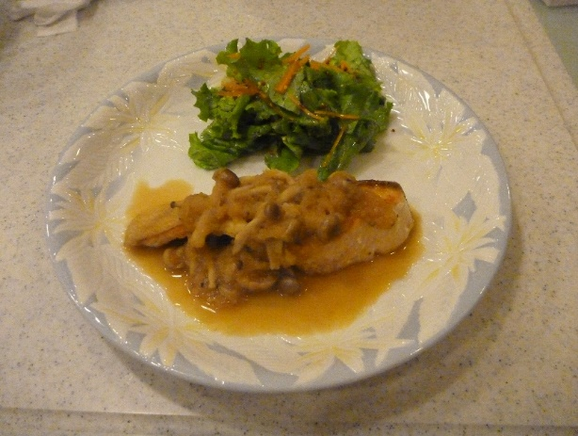

おすすめポイント・一口メモ

季節の・・・

（担当　　　　　　　）